EXPERIMENT -4

4. CREATE A SIMPLE CLOUD SOFTWARE APPLICATION FOR CAR BOOKING RESERVATION SYSTEM USING ANY CLOUD SERVICE PROVIDER TO DEMONSTRATE SAAS.

AIM:
To Create a simple cloud software application for Car Booking Reservation System using any Cloud Service Provider to demonstrate SaaS.

PROCEDURE:
step1: Go to zoho.com.
step 2: Log into the zoho.com.
step 3: Select one application step.
step4: Enter application name as Car Booking Reservation System.
step 5: Created new application as Car Booking Reservation System.
step 6: Select one form
step 7: The software has been created.

IMPLEMENTATION:

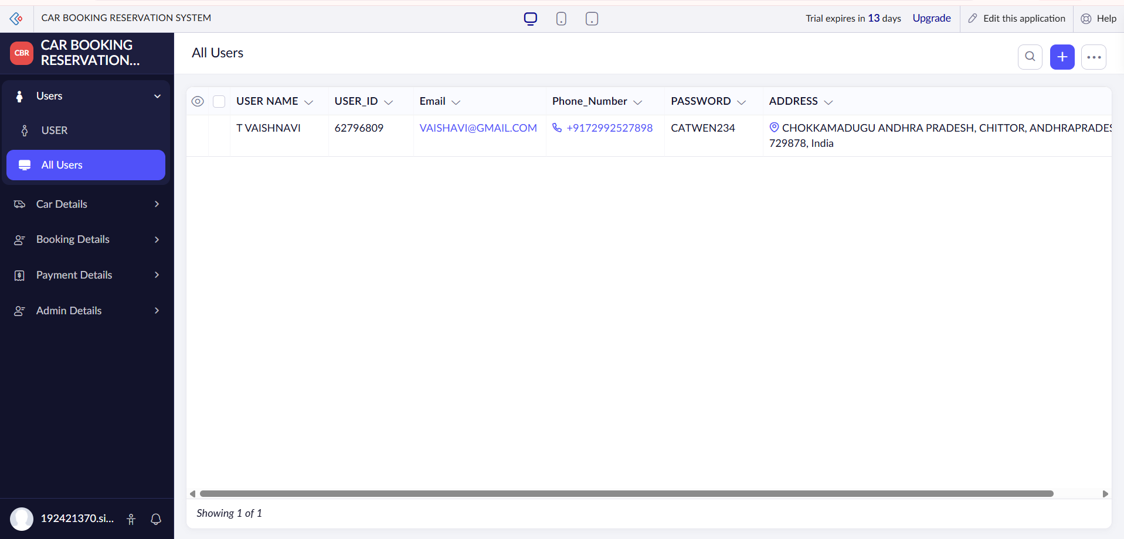
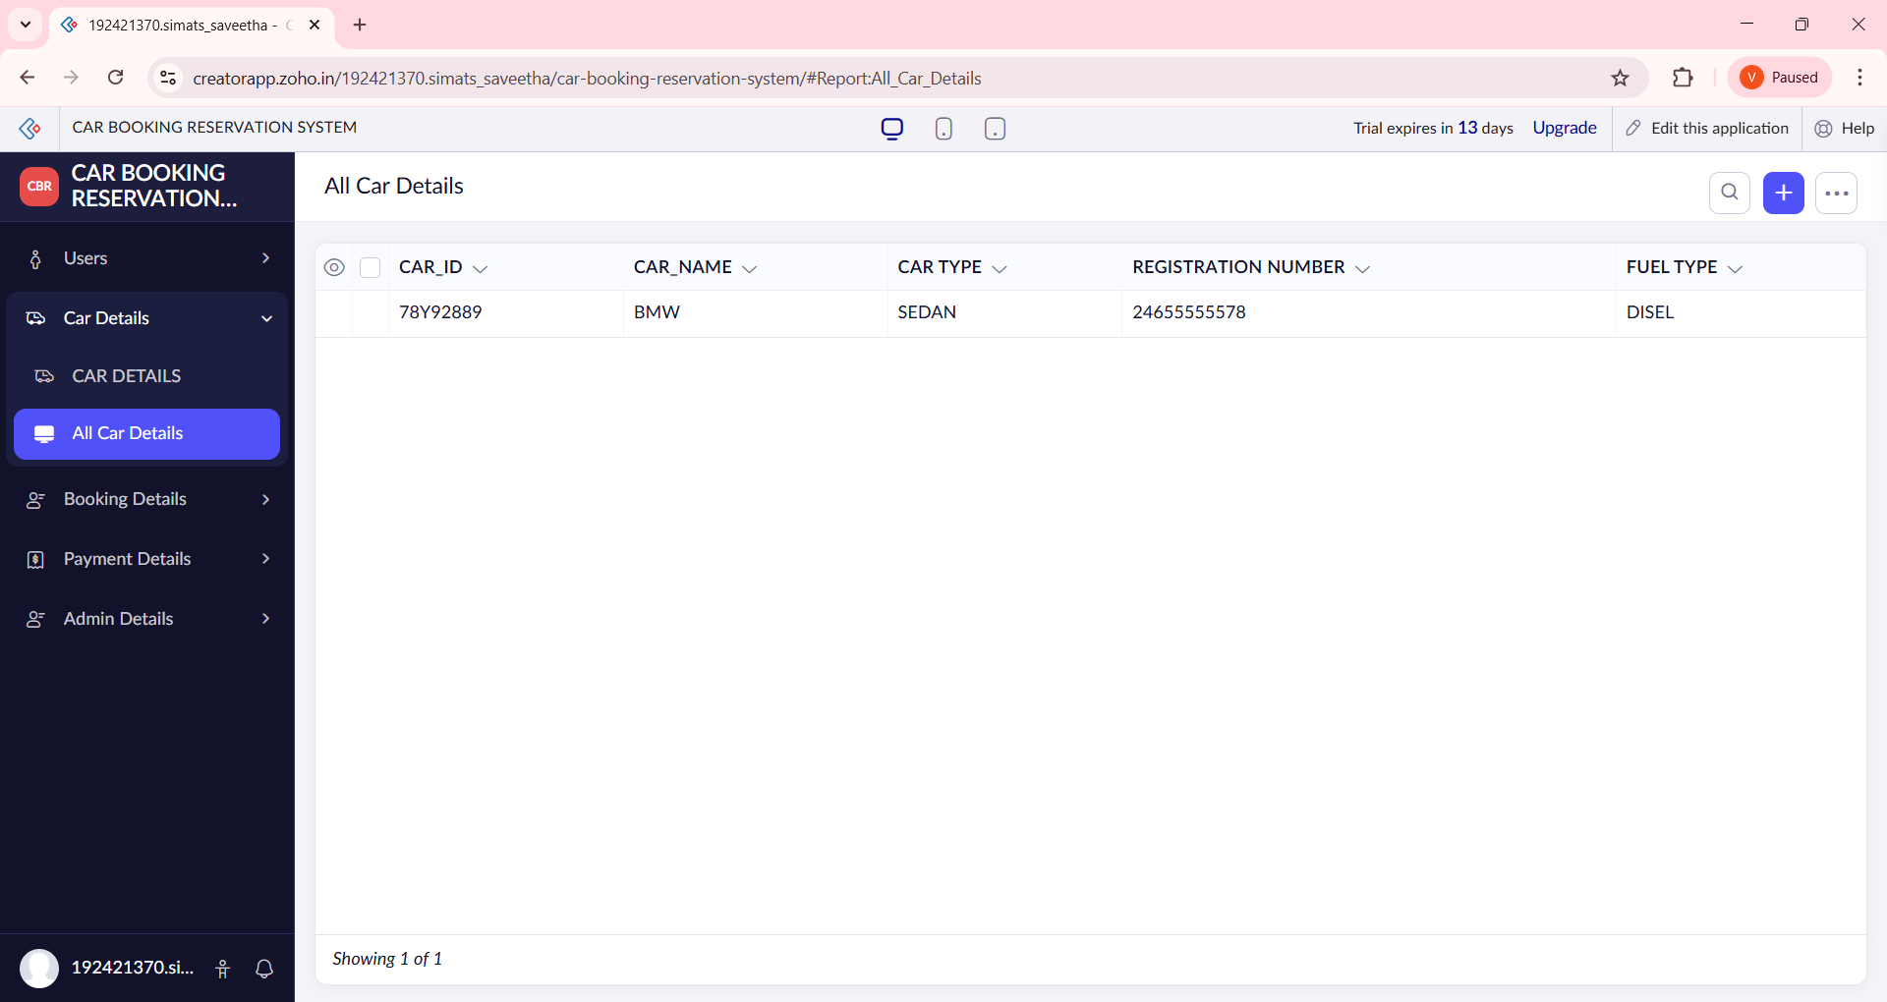
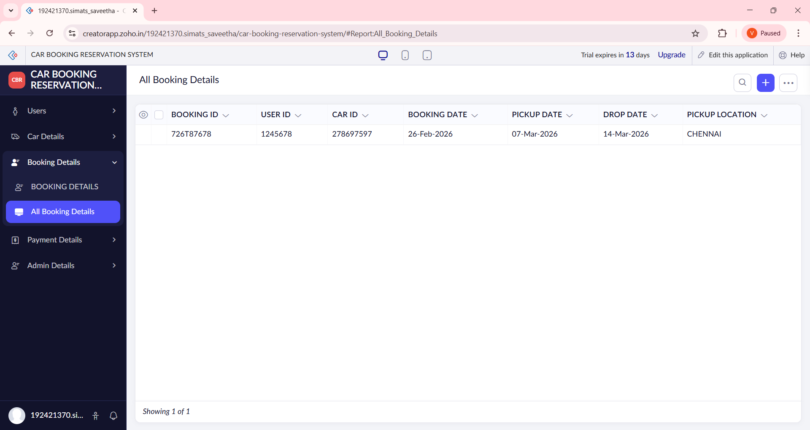
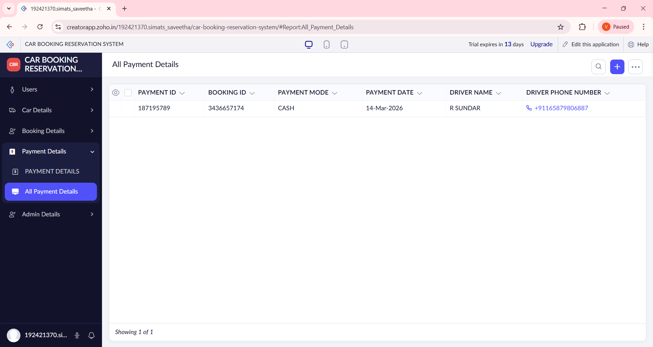

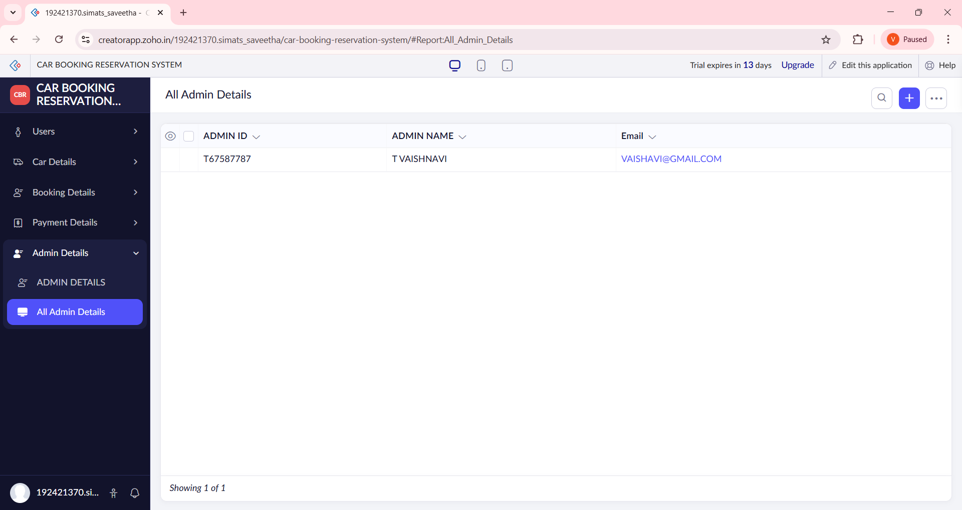

RESULT:
- The Car Booking Reservation System was successfully created and deployed on the cloud.
- Users can:
  - Enter customer details and car booking information
  - Reserve cars online
  - View all booked cars instantly
- Booking details are stored securely in the cloud database.
- The application is accessible anytime and anywhere using a web browser.
- No installation or local setup is required by users.
📌 Hence, the application successfully demonstrates Software as a Service (SaaS).

